pima-decisionTree.ipynb (Set 1 code)

Decision Tree

1) If we change the depth from 2 to 4 accuracy decreases.
dtree = DecisionTreeClassifier(max_depth=4, random_state=42)
Misclassified samples: 62
Accuracy: 0.73

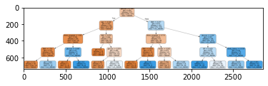

Classification –Decision Trees - Basic Tutorial

1) When depth = 3 When depth = 4
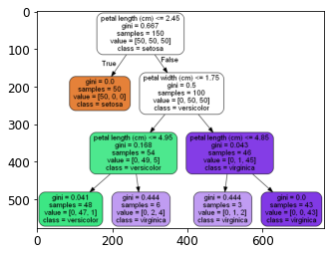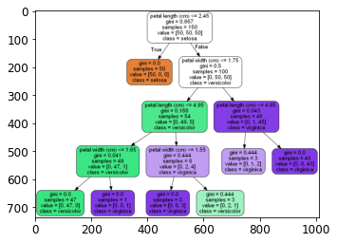
Gini Impurity is the probability of incorrectly classifying a randomly chosen element in the dataset if it were randomly labeled according to the class distribution in the dataset.
If we have C total classes and p(i) is the probability of picking a data point with class i, then the Gini Impurity is calculated as
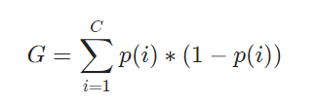

2) class probabilities for petal_len 1 cm and petal_width 0.5 cm :-
[[1. 0. 0.]]
class name :- (0=Setosa, 1=Versicolor, 2=Virginica)
[0]

Classification – Classification Decision Trees and KNN

1) The 3 algorithms used are:
* Decision tree classifier
* Random forest classifier
* KNN classifier
among these 3 Random forest classifier is best because it uses ensemble learning.

2) All the previous algorithms uses non-linear classification, but logistic regression uses linear classification.

File “DTRegression.ipynb”

1) Yes, the decision tree produced is over-fitted.

2) In order to reduce over-fitting we can stop growing the tree before the tree is fully grown to perfectly fit the training data or we can use Random forest classifier.

3) The Predicted insurance value for persons with Age 55 is 20000.

File “CellStrat - Decision Trees – Regression.ipynb”

1) When depth = 3 When depth = 4
If we go on increasing the max_depth over-fitting increases.

2) When max_depth is 20 the output is over-fitted we will get 8 leaf nodes.
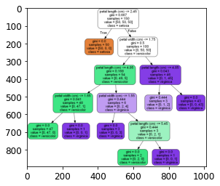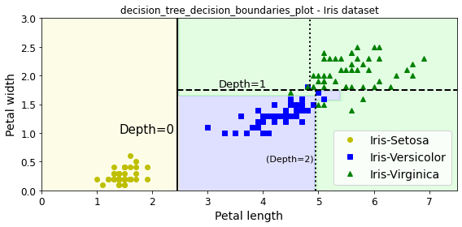

3) class probabilities for petal_len 3 cm and petal_width 1 cm :-
[[0. 0.90740741 0 .09259259]]
class name :- (0=Setosa, 1=Versicolor, 2=Virginica)
[1] (Versicolor)

5) MSE (Mean Squared Error) represents the difference between the original and predicted values extracted by squared the average difference over the data set.
Samples is the total number of values that satisfies the given condition of the node.
Values is the average of the predicted y values of that node.

6) In the decision tree having max depth = 2 there are 4 leaf nodes and max depth = 3 there are 8 leaf nodes.
In the graph of max depth = 2 and having noisy quadratic set of points is more scattered from the predicted values of y but in the graph of max depth=3 the points are more close to the predicted y values.
The average values are the average of all the predicted y values for each of the given nodes.

7) The average value of y for the node after the FIRST split when x1 <= 0.197 is TRUE is 0.689

8) No restrictions on the growth of the decision tree leads to over-fit.

9)
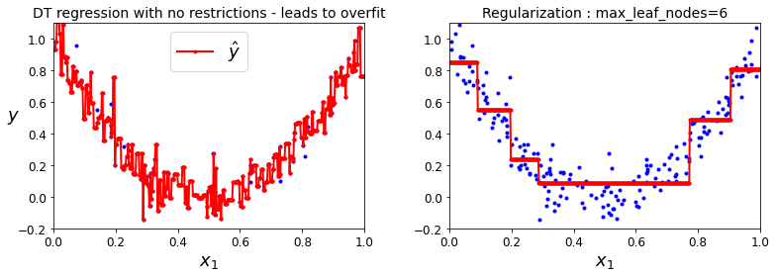
max_leaf_nodes is a hyperparameter that sets a condition on the splitting of the nodes in the tree and hence restricts the growth of the tree.
In the above example we can see max_leaf_nodes=6 which means the splitting is restricted to maximum of 6.

File “Rfregression.ipynb”

1) Yes, RFRegression is better performer than Decision Tree Regression because Rfregression takes mean value of the resuts from decision trees.
Random Forest reduces the risk of over-fitting and accuracy is much higher than a single decision tree.

2) The output insurance value for Age 60 with n_estimators = 10 is 30500.
val = 60
predictionRF = RFregressor.predict ([[val]])

print ("RF prediction = ", predictionRF)

RF prediction = [30500.]

3) n_estimator is a parameter used to control the number of trees to be used in the process.
When we change the n_estimators to 2 the number of decision trees to be used is reduced to 2, thus reducing the accuracy of the model.

RandomForestRegressor(n_estimators=2, random_state=0)

